Project Design Phase-II
Data Flow Diagram & User Stories

Date | 04 February 2026
Team ID | LTVIP2026TMIDS90283
Project Name | rising waters: a machine learning approach to flood prediction

Data Flow Diagrams:
A Data Flow Diagram (DFD) visually represents the flow of data in the Flood Prediction System. It illustrates how input data is collected from users, processed through machine learning algorithms, and transformed into meaningful flood risk predictions.
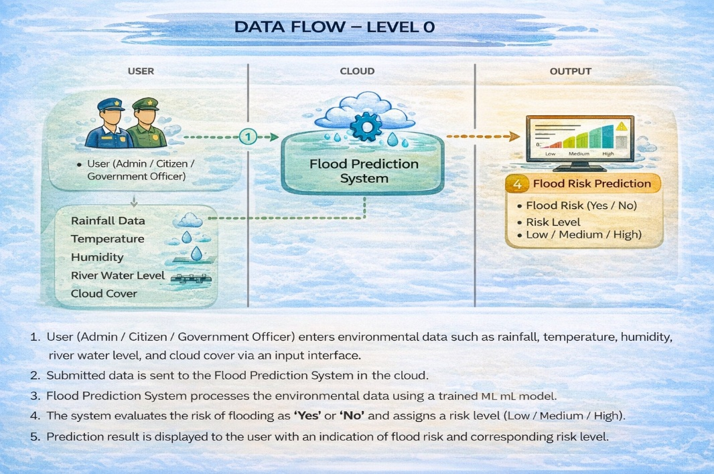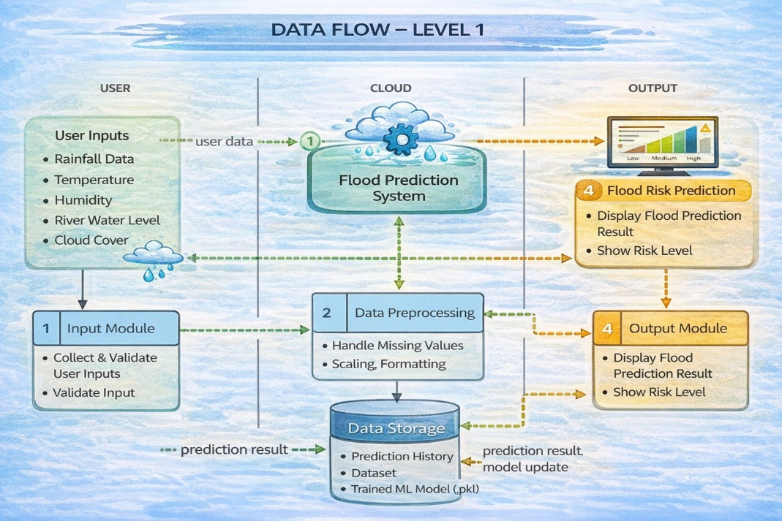
In Level 0 DFD, the user interacts with the Flood Prediction System by entering environmental parameters such as rainfall, temperature, humidity, and river water levels. The system processes the data using a trained machine learning model and returns the prediction result.
In Level 1 DFD, the system is divided into multiple modules including input validation, data preprocessing, prediction module, and result display. The machine learning model processes the cleaned data and generates a prediction indicating whether a flood is likely to occur.
The system also maintains data storage components for storing datasets, trained models, and prediction history.

User Type | Functional Requirement | User Story ID | User Story | Acceptance Criteria | Priority | Release
Citizen | Prediction | USN-1 | As a user, I can enter environmental data to predict flood risk | I can see flood prediction result | High | Sprint-1
Citizen | Result View | USN-2 | As a user, I can view flood risk level | Risk level is displayed clearly | High | Sprint-1
Admin | Model Management | USN-3 | As an admin, I can update the ML model | Updated model is saved | Medium | Sprint-2
Admin | Data Management | USN-4 | As an admin, I can manage dataset | Dataset is stored and updated | Medium | Sprint-2

